Tutorial 2:

Welcome back to the advanced users tutorial to use uiz. We’ll focus on “parenting” in this tutorial. If you have never heard of this concept, following the basic tutorial might be a better idea. The explanation in here will be very brief.

Parenting in uiz, is putting one object in another. An example would be a window which has multiple buttons inside of it. It’s tree would look like:

IMAGE 3:

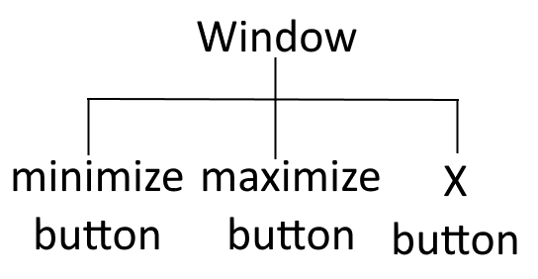

When an parent is set, some of the parents properties will influence the child. For example, when the position of a parent moves 5 pixels to the left, the child will also move 5 pixels to the left. This will work for all different systems like alpha and “containment”(covered later).

The position of a child is defined by it’s own defined position, and the position of it’s parent. For example: a parent might be at position (100,150). The specified position of the child is (100,25). What will happen now is the position of the child will add up to (200,175).

Now, remember the 4 important points? Creating, parenting,variables and fixing. Parenting is in here because it is gives the structure to your ui. You don’t always need to set a parent but ofter you do.

Quick technical detail here: If you didn’t set a parent for your object, then the default parent for your object is obj_uiZ_controller. Which is an object from which only one exists and should exist. This object is created by using uiz_init().

Example:

Here we put a “square” inside a “gradientsquare”:

[CODE]

///Example 6:

//create event of a newly created object.

//initialize uiz

uiz_init()

//create our gradientsquare object

gradient=uiz_c(obj_uiZ_gradientsquare)

//our parent is the uiz controller object.

//setup some variables

gradient.posinframex=px;

gradient.posinframey=px;

gradient.posvalx=50;

gradient.posvaly=50;

gradient.posvalwtype=px;

gradient.posvalhtype=px;

gradient.posvalw=200;

gradient.posvalh=200;

//fix our gradientsquare object.

uiz_fixgeneralpos(gradient)

//create our square object

square=uiz_c(obj_uiZ_square)

//set the parent

uiz_setparent(square,gradient)

//setup some variables

square.posinframex=px;

square.posinframey=px;

square.posvalx=25;

square.posvaly=25;

square.posvalwtype=px;

square.posvalhtype=px;

square.posvalw=40;

square.posvalh=50;

//fix our square object.

uiz_fixgeneralpos(square)

[/CODE]

Which should look like:

IMAGE 4:

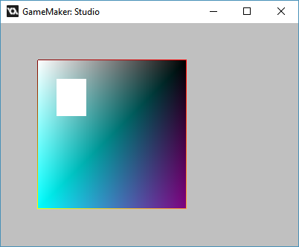

I hope this was somewhat clear. Parenting is an important concept to understand and if you don’t, you should look into the basic uiz tutorial. Later, parenting will come back in advanced structures like grids, frameset, etc…. Until next tutorial!